Homework for Chapter 7: Drawing Causal Diagrams

1. You are making a simplified causal diagram to represent the data generating process of viewership for a TV show. Which of the following is true?

Answer: a.

* 1. The diagram should include a variable for “number of celebrities in the cast”
  2. The diagram should contain one variable for “show airs in the evening” and another for “show doesn’t air in the evening”
  3. The diagram should not contain a variable for “show budget” because budgets are often secret and the researcher can’t measure them
  4. The diagram should contain the variable “review score in the Jefferson Weekly,” which is the newspaper published by the students at Jefferson High School, with a readership of about 120 people.

1. Draw a causal diagram for the research question “do long shift hours make doctors give lower-quality care?” that incorporates the following features (and only the following features):
   1. Long shift hours affect both how tired doctors are, and how much experience they have, both of which affect the quality of care
   2. How long shifts are is often decided by the hospital the doctor works at. There are plenty of other things about a given hospital that also affect the quality of care, like its funding level, how crowded it is, and so on

(Instead of putting “hospital” as a variable with two arrows coming from “funding level” and “Crowded level”, I think directly use “Hospitals’ funding levels” and “Hospital’s crowded level” would be better and make sense.)

* 1. New policies that reduce shift times may be implemented at the same time (with the timing determined by some unobservable change in policy preferences) as other policies that also attempt to improve the quality of care

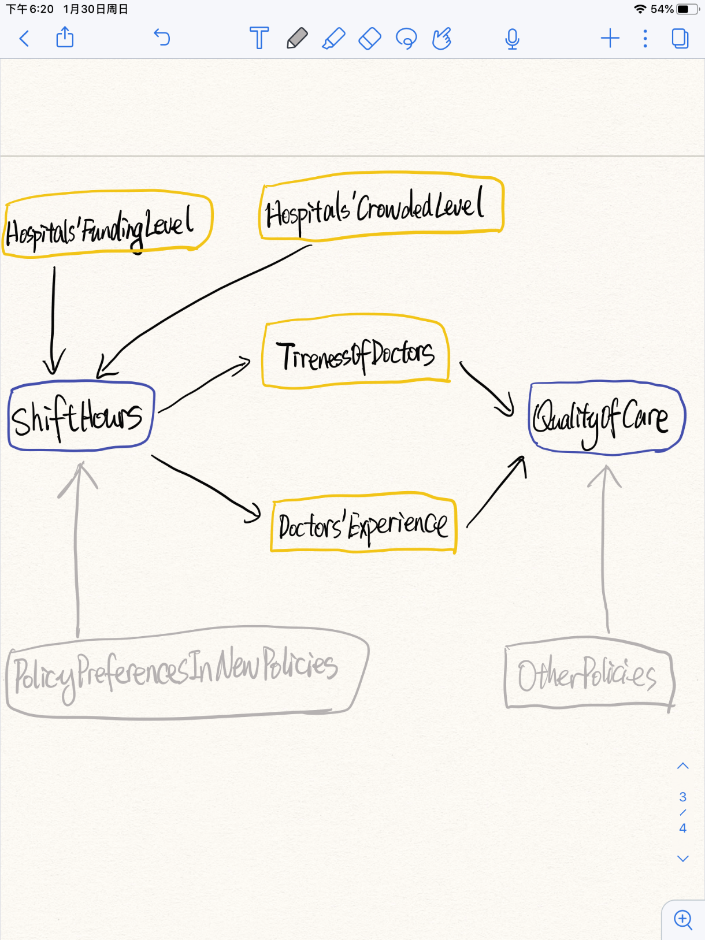

1. Consider this research question: Does the funding level of public schools affect student achievement for students in your country?
   1. What is the treatment and what is the outcome of interest?

Answer: treatment: the funding level of public schools in my country; outcome of interest: student achievement in my country.

* 1. Write down a list of relevant variables.

Answer: Available time on studying; Parents’ degrees; Grandparents’ degrees; Public schools’ budgets; Family Income; Educational Policies; Students’ Intelligence; Government’s budget.

* 1. Which of the variables in your list in part b are causes of both treatment and outcome?

Answer: I think the variable educational policies is the cause of both treatment and outcome. Some preferences in educational policies could causes public schools’ funding levels and some measures of educational policies will affect student achievement too.

* 1. Why might we want to pay extra attention to the variables listed in part c?

Answer: The relevant variables listed in part c are parts of the DGPs and they could cause treatment and outcome directly or indirectly. So we need to pay attention to these variables to better understand the DGPs and the causality.

* 1. Draw a causal diagram of the variables listed in part b.

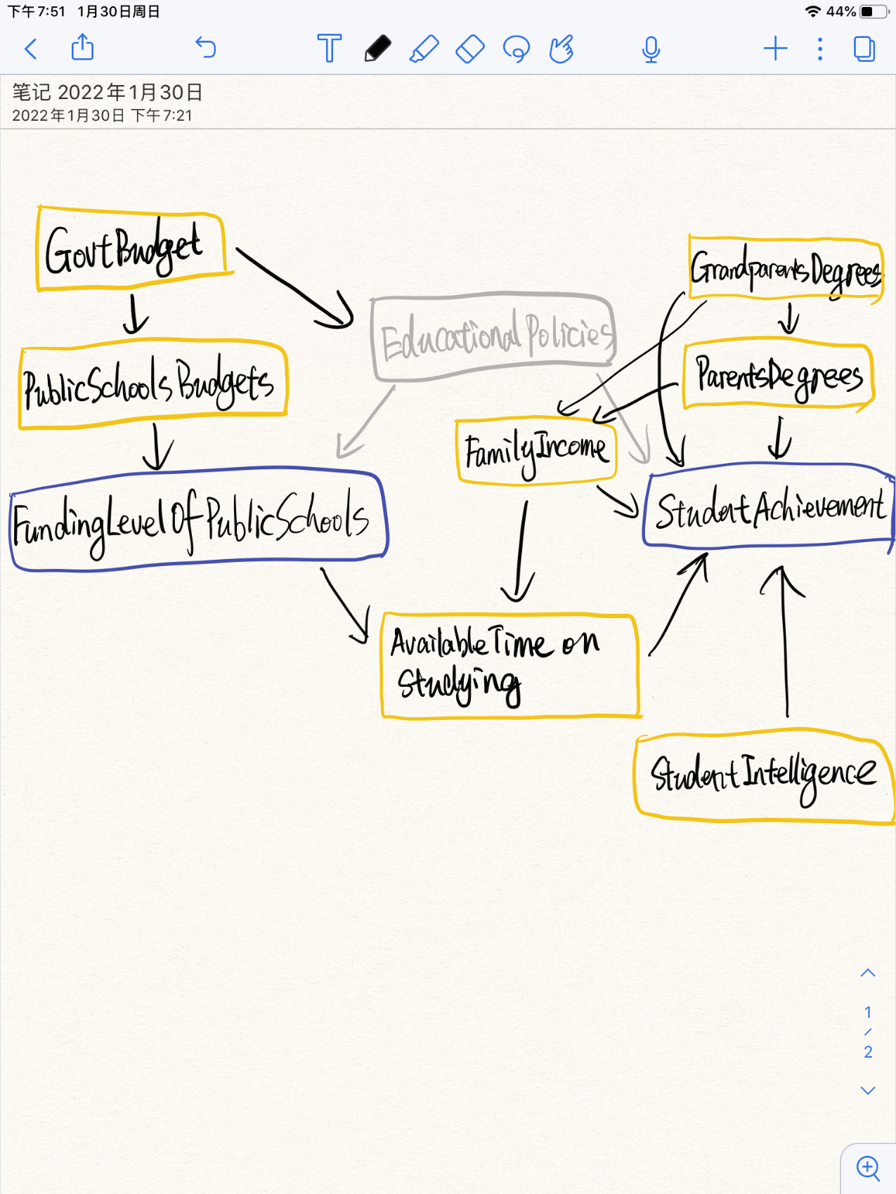

* 1. Simplify the diagram from part e.

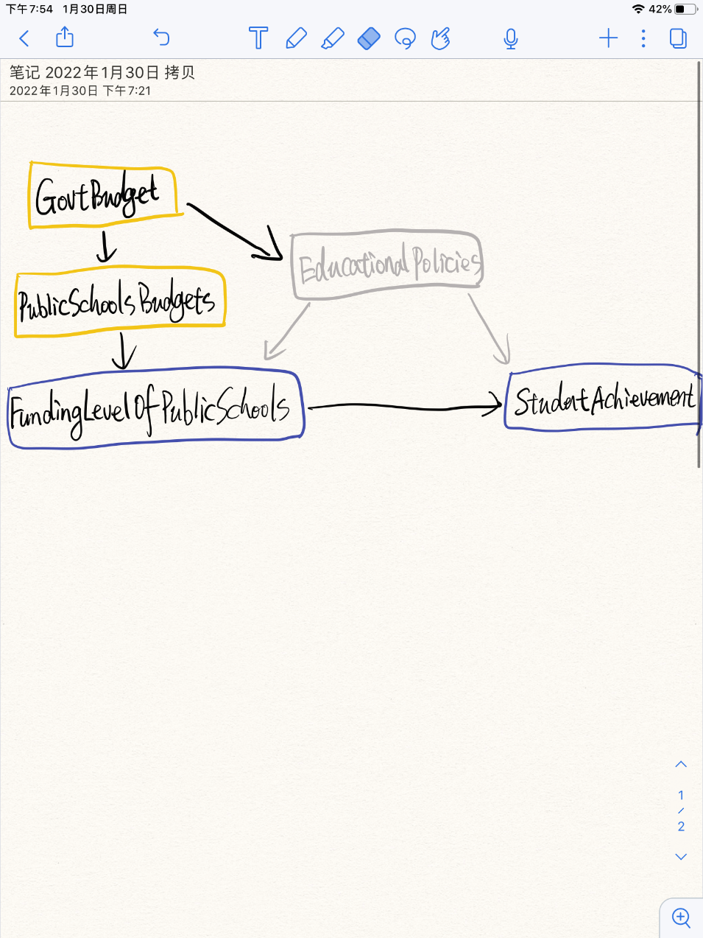

1. Describe the kinds of situations that each of the following could be applied to in order to simplify a causal diagram.
   1. Unimportance

Answer: If a variable’s coming in and going out arrows are likely to be unimportant effects, then we could remove this variable since the effects on it and its effect on other variables are tiny.

* 1. Redundancy

Answer: If variables have the arrows coming in and going out of them from/to the same variable, we could probably combine and describe these variables together so that we could simply diagrams.

* 1. Mediators: If variables are only as a way for one variable affect another variable and without other extra arrows, we can probably remove it and just have the direct effect on diagrams.
  2. Irrelevance

Answer: If a variable is irrelevant to research though it is important for the DGPs or it is not on any path between the treatment and outcome variables, we can probably remove this variable.

1. How can a causal diagram be modified so as to avoid cyclic relationships?

Answer: There are two ways to avoid cyclic relationships: first, we can add a time dimension; second, we can also include an instrumental variable to break the cycle. For example, we can find a source of random variation (instrumental variable) for one of the variables in the cycle, and then focus on the part of the variable driven by randomness, finally the cycle will disappear.

1. Think of a research question in your field of interest.
   1. What is the cause variable and what is the outcome variable?

Answer: Cause variable: Number of positive reports on the government that people read; outcome: Nationalism.

* 1. Write down a list of between 5 and 10 relevant variables in the data generating process.

Internet Access; Exposure to news reports; Age; Degree; Types of jobs; Parents’ degrees; Parents’ political preference.

* 1. Draw a causal diagram incorporating all the variables from part b.

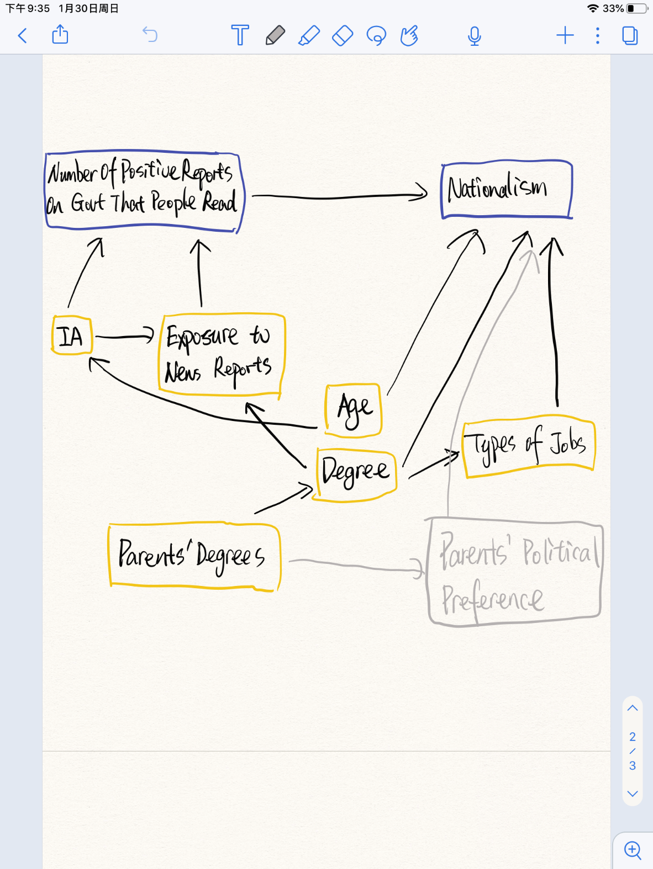

* 1. Stop working on this problem for fifteen minutes and do something else. Then come back, look at your causal diagram from part c again, and describe one bad assumption you think it made, or something it left out.

Answer: In this diagram, I assume that national education has no effect on all of these variables. But I find that national education might have an effect on both the cause variable, the number of positive reports on government that people read, and the outcome variable, nationalism. People who have experienced national education might be more likely to read more positive reports on the government. And national education might strengthen nationalism.

1. Consider the diagram below. It depicts a cyclical relationship between student achievement and motivation. If students achieve more (i.e., score well on exams), then their motivation goes up, and if their motivation goes up, they achieve more. Change the diagram so that the relationship is not cyclic anymore.  
   

Answer:

